**Appendix 101 – Household Demographics**

This data is taken from the US Census

<https://www.census.gov/quickfacts/fact/table/philadelphiacountypennsylvania/INC110218#INC110218>

This screenshot shows that the number of households is around 600,000.

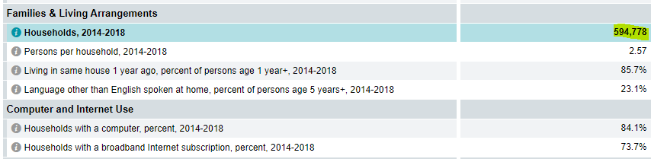

This screenshot shows that the median income of a Philadelphia householder is $43,744

